**Assignment 1 :**

**The data Virtualisation for the given data set with setting Profit as target with multiple factor such as**

1. R&D spending:
2. *Administration spending:*
3. *Marketing spending*
4. *State*

***Screenshots for the Data Exploration :***

**Profit by R&O Spend**

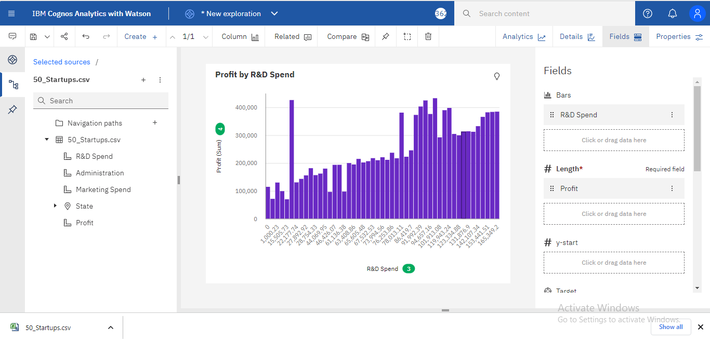

**Profit by Administration**

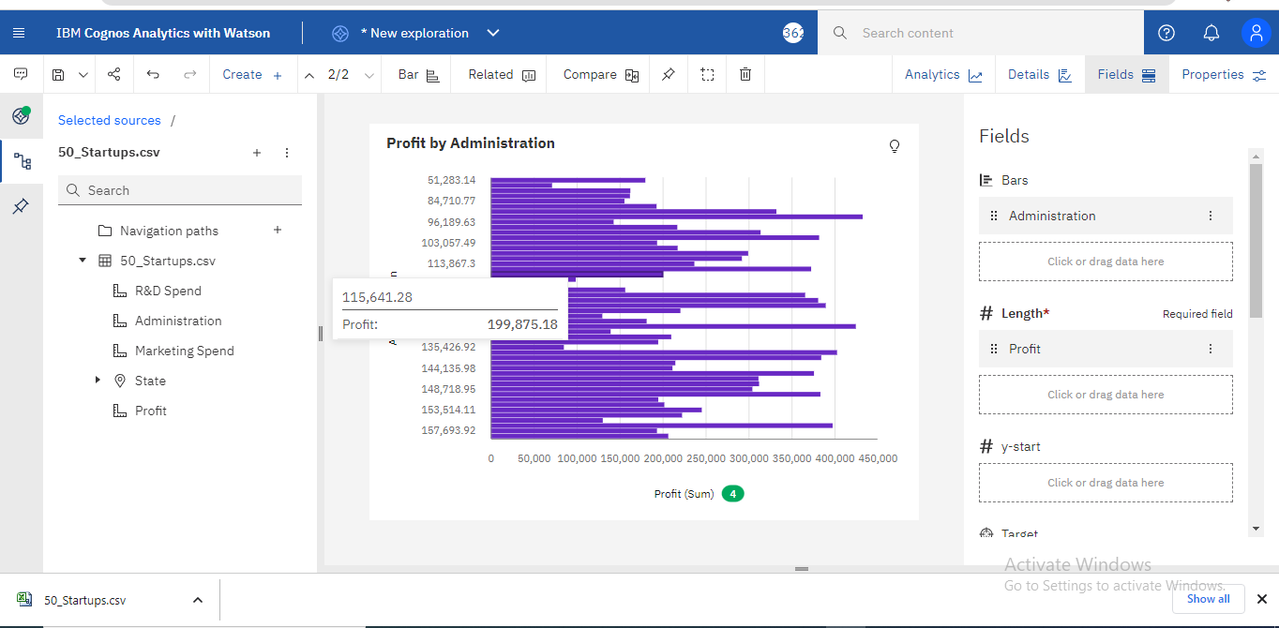

**Profit by Marketing spend**

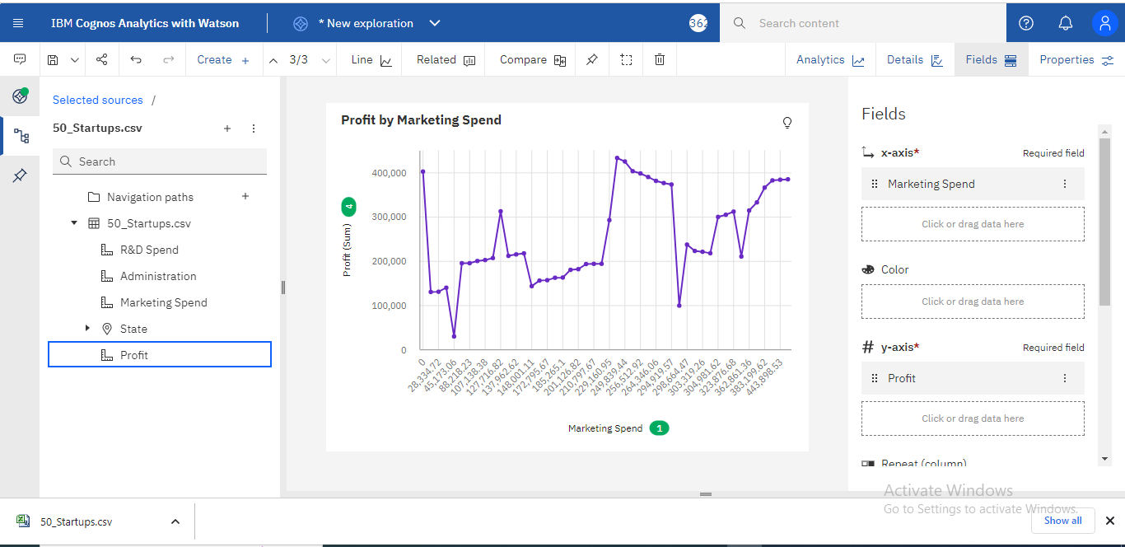

**Profit by State**

